**Template 4 (Candidate Acknowledgement Form)**

**Name:**

Name of Current Employer:

Date of Employment: (From 27-Dec-2018 To Till Date)

Dear Debjyoti Dhar,

As a follow up to your recent discussion with Accenture, would you please confirm by signing this letter that during employment at your current employer in the last 24 months you have not been   involved either directly or indirectly in matters related to Accenture.

CANDIDATE SIGNATURE:

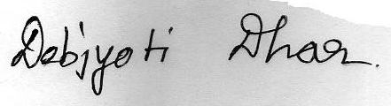

DATE: 04-Mar-2021

PLACE: Kolkata, W.B.